NAME: KANKANALA AKSHITHA REDDY
H-NO:2403A51007
BATCH-01
SET-B
TASK-01
Create a Python function that converts an amount from one currency to another using exchange
rates stored in a dictionary. Use GitHub Copilot along with VS Code. Use Few shot prompting.
PROMPT:
generate a python code to convert one currency to another using exchange rates stored in the dictionary and provide an option to give input
#convert_currency(100, 'USD', 'EUR', exchange_rates) -> 92.0
# convert_currency(200, 'GBP', 'JPY', exchange_rates) -> 36846.1538
# convert_currency(50, 'EUR', 'USD', exchange_rates) -> 54.3478
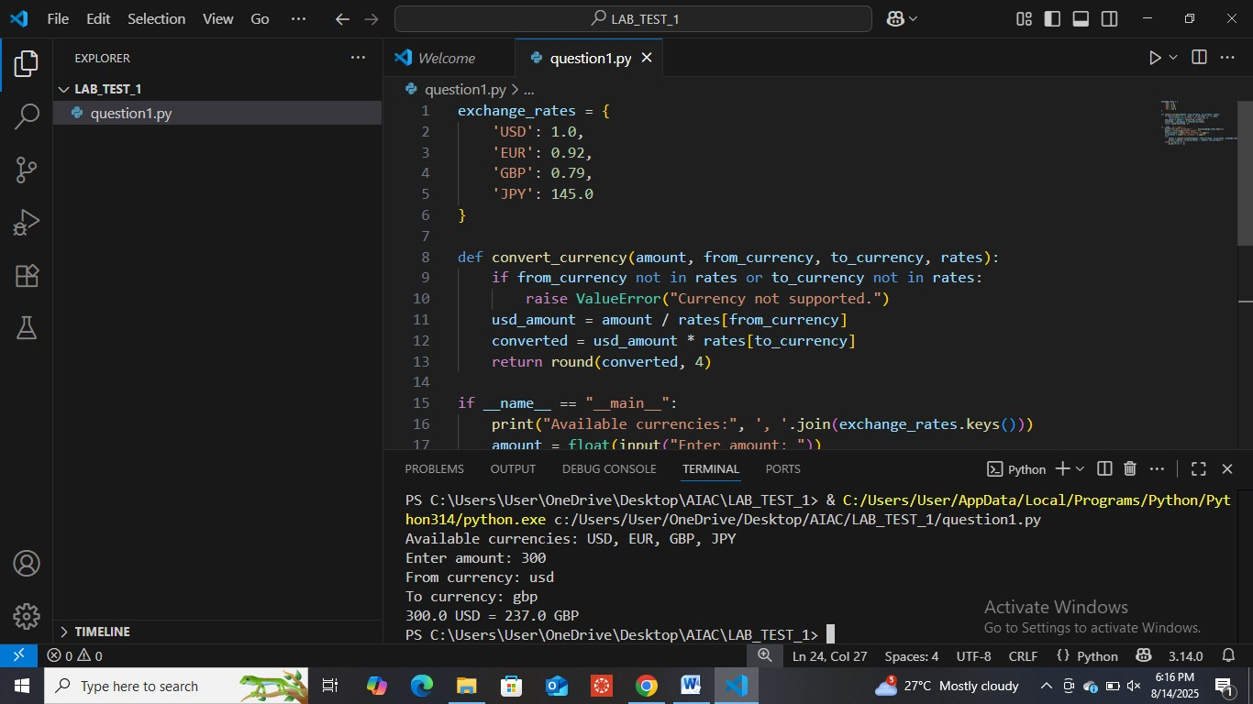
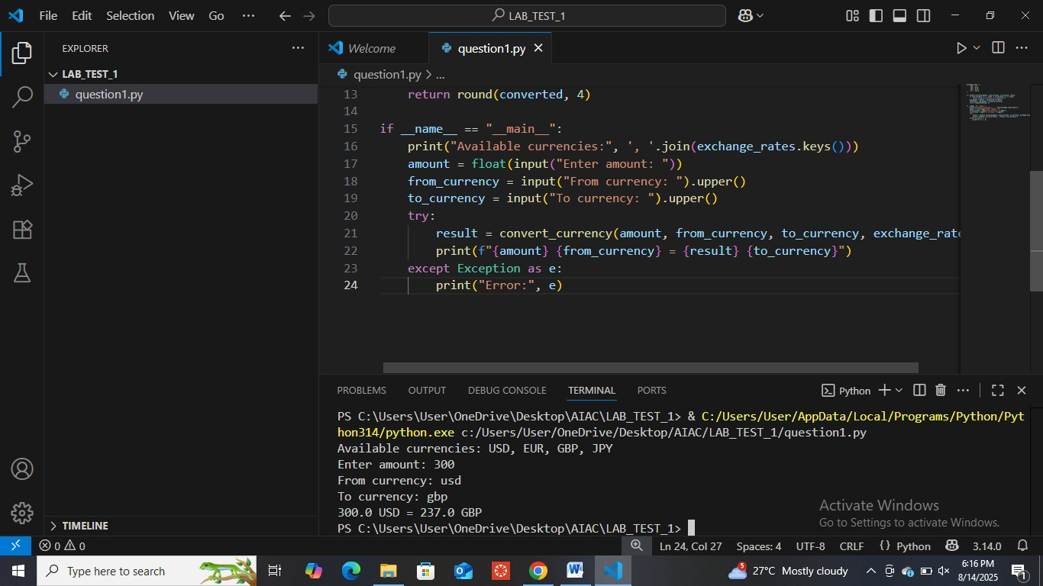
TAK-02
Write a Python program to extract all email addresses from a block of text using regular
expressions. GitHub Copilot along with VS Code. Use zero shot promptingPROMPT: generate a Python code to extract all email addresses from a block of text using regular
expressions.provide an option to give input
# extract_emails("Contact us at sru@gmail.com or support@sru.org for help.")
# Output: ['sru@gmail.com', 'support@sru.org']
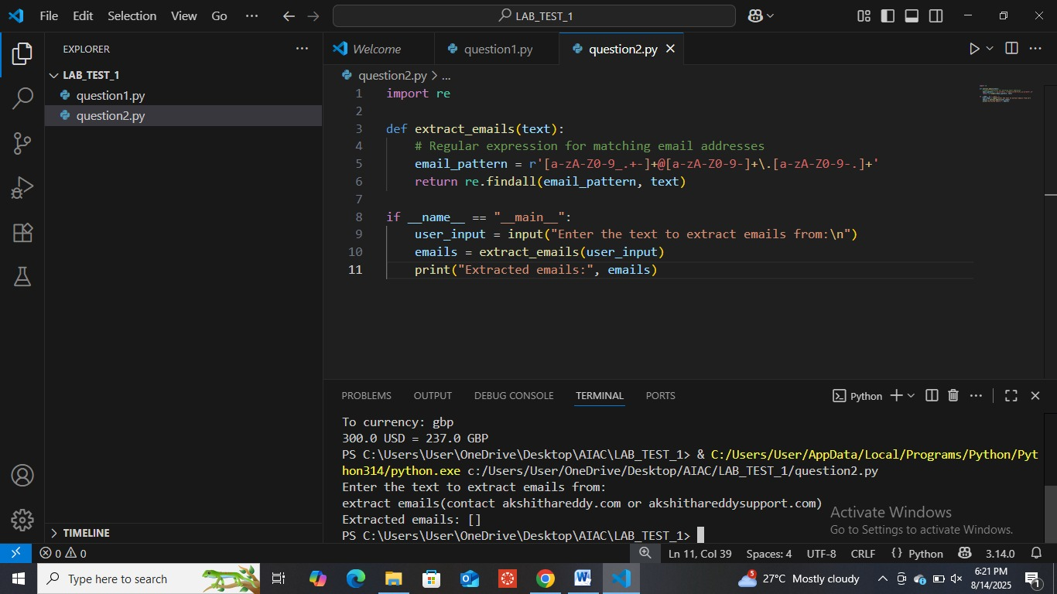

TASK-03
Given a list of movies with their genres, Write a Python function that recommends movies
based on a user’s preferred genre. Use the Cursor AI tool. Use few shot prompting
generate a Python code to suggest moviesbased on a user’s preferred genre. provide an option to give input. provide few shot prompting example
# Few shot prompting examples:
# movies = [
# {'title': 'gita govindam', 'genre': 'romance'},
# {'title': 'Srinivasa kalyanam', 'genre': 'family'},
# {'title': 'shathamanambavathi', 'genre': 'family'},
# {'title': 'anabelle', 'genre': 'horror'}
# ]
# recommend_movies(movies, 'horror') -> ['anabelle']
# recommend_movies(movies, 'Romance') -> ['gita govindam']
# recommend_movies(movies, 'family') -> ['Srinivasa kalyanam','shathamanambavathi']
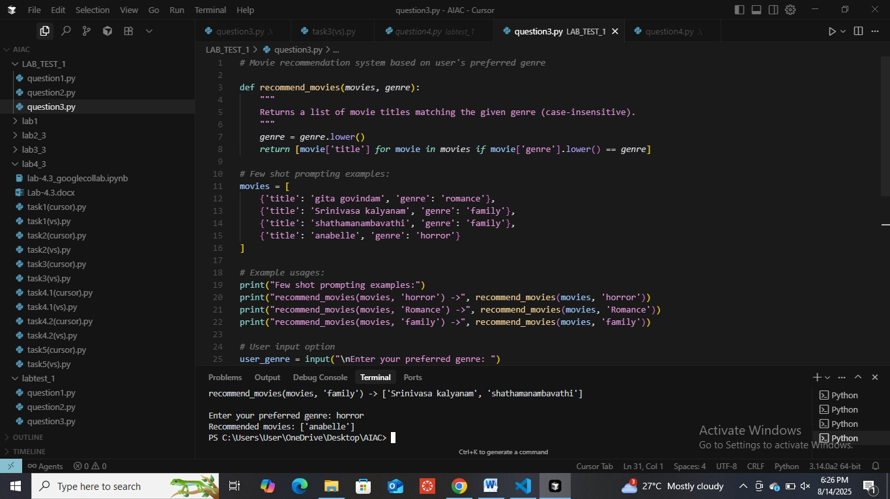
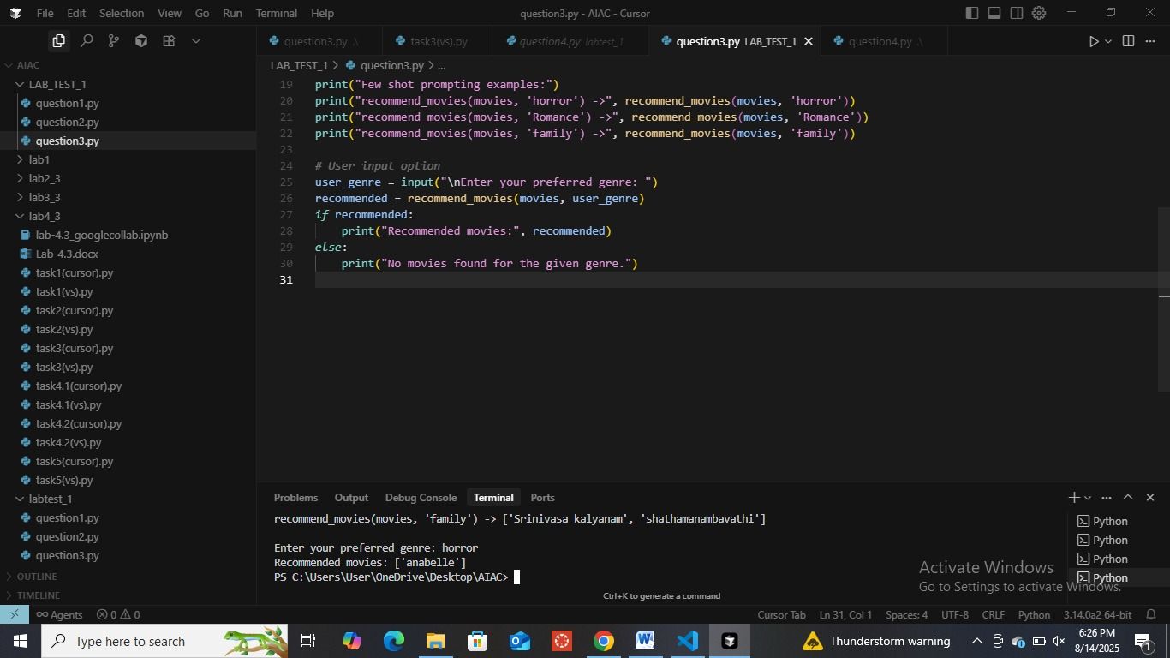

TASK-04
Write Python code that reads a CSV file containing student names and marks in 3 subjects.
Calculate the total and average marks for each student. Use the Cursor AI tool.
PROMPT:
Write Python code that reads a CSV file containing student names and marks in 3 subjects.
Calculate the total and average marks for each student. Use the Cursor AI tool.
